**Monday**

06:45-07:30 Body Combat 

11:30-12:00 CORE 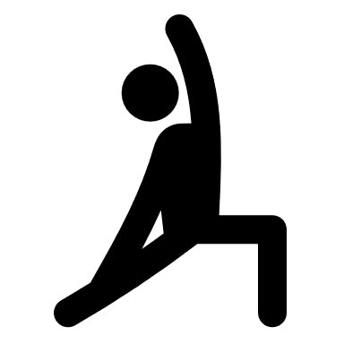

13:00-13:30 GRIT 

17:00-17:30 CORE 

20:00-20:30 Body Combat 

**Tuesday**

06:45-07:15 CORE 

12:30-13:00 CORE 

17:00-17:30 GRIT 

**Wednesday**

07:00-07:30 GRIT 

12:00-12:30 Combat 

17:00-17:30 CORE 

**Thursday**

07:15-08:00 Body Balance 

08:25-09:10 SHbam 

12:30-13:00 Body Pump 

**Friday**

07:30-08:00 CORE 

13:00-13:30 GRIT 

17:00-17:30 GRIT 

17:45-18:30 Body Pump 

18:30-19:15 Sh’bam 

**Saturday**

08:15-08:45 GRIT 

09:00-09:30 Body Combat 

12:45-13:30 Body Pump 

17:00-17:30 Body Combat 

**Sunday**08:30-09:00 CORE 

17:00-17:45 Body Balance 

**Health Club Opening Times**

Monday-Friday 06:45-22:30

Saturday-Sunday 08:00 -20:00



Follow us @thenationalbadmintoncentre