**Monday**

07:00-07:45 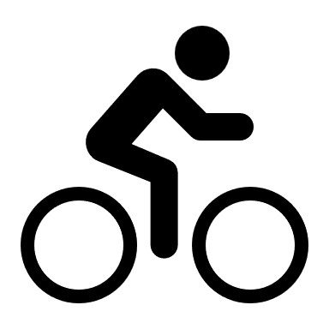 RPM 45  
12:00-12:30  RPM 30

12:30-13:00  Sprint 30

17:00-17:30  RPM 30

20:00-20:30  RPM 30

**Tuesday**

09:30-10:15  RPM 45

12:15-13:00  RPM 45

19:30-20:15  RPM 45

**Wednesday**

06:50-07:35  RPM 45

09:30-10:00  Sprint 30

12:30-13:15  RPM 45

**Thursday**

06:50-07:35  RPM 45

12:00-12:30  Sprint 30

13:00-13:30  RPM 30

16:45—17:15  RPM 30

**Friday**

07:00-07:30  Sprint 30

09:30-10:15  RPM 45

12:30-13:00  Sprint 30

13:00-13:30  RPM 30

18:00-18:45  RPM 45

**Saturday**

12:00-12:30  RPM 30

14:00-14:30  Sprint 30

**Sunday**08:30-09:00  RPM 30

12:00-12:45  RPM 45

**Health Club Opening Times**

Monday-Friday 06:45-22:30

Saturday-Sunday 08:00 -20:00

Email us at [nbc@badmintonengland.co.uk](mailto:nbc@badmintonengland.co.uk).

Follow us @thenationalbadmintoncentre