Job Description |  | 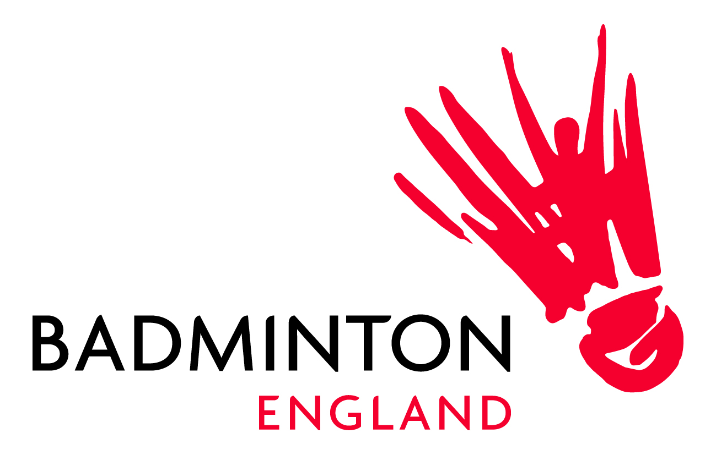
Title: | Catering Assistant – Part-time (16-24 hours per week)
Team: | NBC
Responsible to: | Catering Manager
Office Location: | National Badminton Centre, Milton Keynes
Salary: | Grade 2- £10.50 p/h
Join our team at the National Badminton England Centre
Job title: Catering Assistant (part time)
Team: NBC
Date posted: 11/10/2022
Application closing date: 28/01/2022
Location: National Badminton Centre, Milton Keynes
Working hours: 16-24 hours per week, including weekends
Salary: £10.50 p/h
How does the  role supports  our vision: | The Barn-Restaurant at the National Badminton Centre is at the heart of everything that we do. Our team is crucial to the success of the Barn-Restaurant by providing a friendly, affordable, and tasty service for all our customers.  Here at the National Badminton Centre, you’ll find:  - The Barn-Restaurant  - Full sized, indoor, Badminton courts to use with friends  - The National Badminton Centre Lodge which is a 25-room hotel that offers a dedicated and friendly service  - Fully equipped gyms and studio’s  Our customers include employees based at the NBC, badminton players, badminton coaches, gym members and member of the public so there is never a dull day.  If you know that you can provide a great service for our customers, then we would like to hear from you.
The Person: | The National Badminton Centre are seeking a part time Catering Assistant to become a crucial member of the Barn-Restaurant team. You will be responsible for the preparation of our fresh food, provide an outstanding customer service, as well as washing up and cleaning.
Successful Candidate: | The successful candidate will have:  - Experience of being a multi-skilled team member assisting where required, this role includes different elements of managing food preparation, serving and end of shift clear downs  - Food Hygiene Level 2 & Food allergens Level 2 (on-site training can be provided)  - A real passion for delivering excellent customer service  - Be smart in appearance  - Possess excellent communication and interpersonal skills  - Be energetic with a passion to do a great job  - Demonstrate a passion for food  - Have a can-do attitude and be a team player
Employee Benefits | - 25 days annual leave, plus bank holidays and 1 additional day for each year of service up to a maximum of 30 days (pro rata)  - Free onsite gym membership for you and a partner  - Book a badminton court, free of charge, based at the NBC  - Free onsite parking  - Occupational sick pay  - Free tickets to badminton events  - Free membership with Perkbox which include:  - Free perks  - Reward and Recognition  - Medical  - Online benefits

Application Process:

Please send your CV with covering letter to hr@badmintonengland.co.uk

To find out more, please visit our website here

Applications to be received no later than Friday 28 January 2022.

Interviews to be held in February 2022

We positively celebrate Diversity & Inclusion at Badminton England. Our aim is to become the UK’s most inclusive National Governing Body - for our staff and members, reflecting and connecting with the diverse communities that we serve. We want people from all walks of life to feel valued for their individuality, thrive in our organisation and share a sense of belonging. To find out more about D&I at Badminton England, click here.

