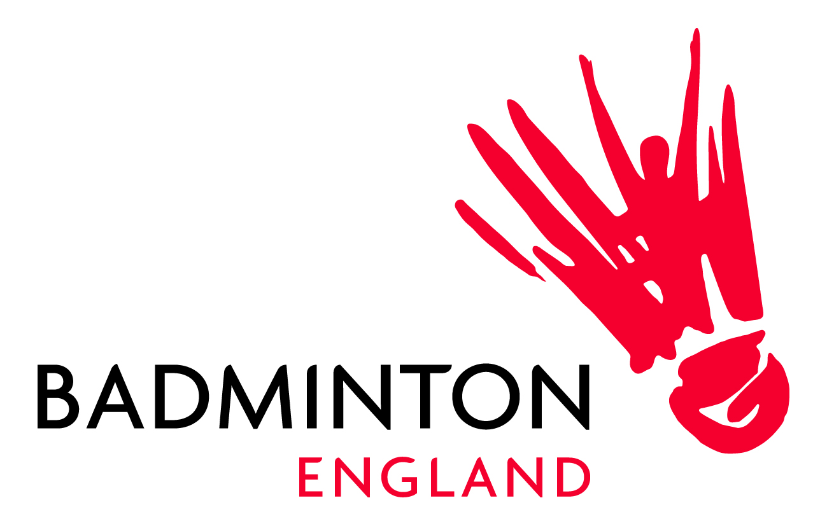

ANTI-DOPING
ANNUAL SUMMARY OF ACTIVITY

The following is an update for the Badminton England (BE) Board on the anti-doping activities that have taken place in 2021 to provide an awareness to Board members on the work BE is doing on anti-doping and in promoting clean sport.

FOR INFORMATION:
- World Anti-Doping Agency (WADA) List of Prohibited Substances and Methods: this was published on 1 October, and take effect from January 1, 2022. BE will be working to ensure all athletes, coaches, support personnel are aware of the new list, including the changes and ensure that any Therapeutic Use Exemption (TUE) are in place before the updated list comes into effect

- CleanSport Education Strategy and Implementation Plan: BE has submitted its draft plan for review by UKAD. BE has identified a SWOT analysis of anti-doping activity across the sport and has identified clear areas of development for the sport over the next 2 years, including:
  - Getting more people educated and trained in clean sport to then help others to learn
  - Working in partnership with UKAD to share resources and information across the sport
  - Creating clean sport ambassadors within the sport
  - Embedding clean sport principles and awareness into coach education, and safeguarding co-ordinator work
  - Promoting clean sport principles through BE newsletters, social media, training camps/events
  - Embedding anti-doping into codes of conduct
  - Further information and a copy of the plan is attached for review and feedback by the Board

- UKAD official testing reports (1 April – 30 June 2021): This report shows that UKAD carried out 2200 tests across all sports in this period, 3 of which were out of competition tests on Badminton players.

- UKAD Assurance Framework: BE is currently compiling records information to submit to UK Anti-doping by December 2021 to demonstrate compliance with the UKAD framework for sports

- UKAD/BE Information sharing agreement: BE has signed an information sharing agreement with UKAD. This is to provide detail of how data will be shared and clear responsibilities between BE and UKAD in doing so.

- Anti-doping website profile: The anti-doping information on the Badminton England website has been viewed 162 times in 2021

- Coach anti-doping education: A total of 73 coaches have been upskilled on anti-doping awareness and information in 2021 via the 8 coaching certificate courses (61 learners) and a Level 3 course (12 learners).

- Player and performance coach anti-doping education: A total of 16 players across the Olympic and Paralympic programme have completed UKAD anti-doping education. Five performance coaches have completed coach clean e-Learning modules, and 2 members of staff have completed the Accredited Advisor e-Learning module.

